10-19-12

Unlearning4 in II Category Learning Preliminary Results

Overview

This is an extension of Unlearning 1 which is Experiment 2 in the JEP:General paper. In that study we had 300 acquisition and 300 reacquisition trials with veridical feedback. However during the intervention phase (in the original summaries we called this extinction) there is a 75% chance of random feedback and a 25% chance of correct feedback.

What we want to do now is introduce a dual task during different stages of the session and for different durations. This is the same dual task that we used in dual task/aggregate feedback study.

The figure below (thanks to Matt) says it all. I do have a few comments.

1. Notice that we are changing from 300 acquisition-300 intervention-300 reacquisition to 300 acquisition-400 intervention-150 reacquisition.
2. We will need some general instructions at the start of the study giving them an overview of the whole task. Then we will need instructions once the dual task is introduced, and a final brief set of instructions telling them that the “no dual task” conditions are back. Cage—go ahead and generate some instructions for each phase using what you already have and your dual-aggregate feedback instructions then run them by me.
3. “random learning” below is the same as unlearning.

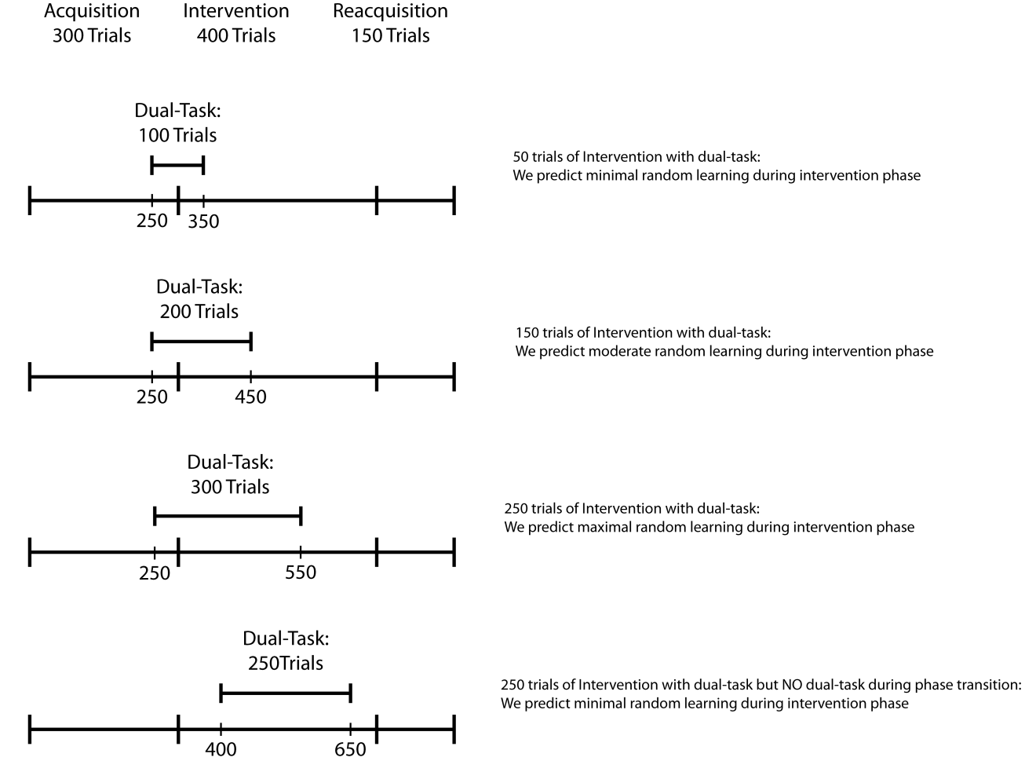

As far as timing on each trial I assume that you used something like the following:

No dual task trials: Stim (resp term) – 1000ms feedback – 500ms iti

Dual task trials: Stim (resp term) – 1000ms feedback – value/size query (resp term) – response – 1000ms feedback – 500ms iti

For lack of better terminology we will call these conditions 1 – 4 from top to bottom of the figure above.

We also need a control condition that has NO dual task trials.

As far as file names lets go with unl41x.dat, unl42x.dat, unl43x.dat and unl44x.dat where unl4 denotes unlearning experiment 4 and the x is the subject number. We will also have unl4cx.dat for the control condition.

Same format at unlearning 1 but add columns for dual task

Let’s start with 10 in each of these 5 conditions.

Extra notes on the dual task:

1. During stimulus 1 presentation in the dual task condition, the stroop stimuli are displayed concurrently to the left and right of the categorization stimulus for 200 ms and are then replaced by a rectangular white mask (one on each side) for 200ms.
2. On 85% of trials the numerically larger number is physically smaller.
3. During the value/size query, on half of the trials the word “value” comes up and on half of the trials the word “size” comes up. This queries the participant to determine which side (left or right) had the numerically or physically larger stimulus.
4. The participant is instructed to perform the numerical task without error and to use whatever is left over to do the categorization task.
5. Participants’ current accuracy on the numerical Stroop task should be indicated at the top of the screen when they received feedback regarding their performance on the concurrent task on each trial. Their percentage correct score should be listed in green if it was above 80% and red if it was below 80%.

Preliminary findings

The conditions above are numbered 1 – 4 from the top to bottom. We have 27-30 subs in each condition. I am going to plot only in 25-trial blocks. I applied the following exclusion criteria:

1. If performance during trials 201-250 is below 40% then drop
2. If dual task performance is below 80% then drop.

This leaves us with the following

N all subjects N following exclusion

Condition 1 30 24

Condition 2 30 23

Condition 3 28 23

Condition 4 27 23

Accuracy data



Stroop accuracy data



Things seem to be smoothing out a bit. Initial acquisition is starting to converge across conditions, although you might expect condition 4 to be better since it has no dual task during blocks 11 and 12. Then again by the end of initial acquisition folks should be using II strategies and thus be minimally affected by the dual task. Condition 1 shows the most extinction but also relearns fastest. This makes sense, since the dual task was only present for 100 trials in this condition. We see less extinction in conditions 2 and 3 and the worst reacquisition in condition 3. Condition 4 has the dual task in the middle of the extinction phase and shows little unlearning and little reacquisition.

This seems promising to me but you guys are the experts on this. If we want to continue, it would probably be best to get to 50/condition since (after exclusions) that would put us at 35-40/condition. The dual task adds noise so we need bigger sample sizes.

Let me know